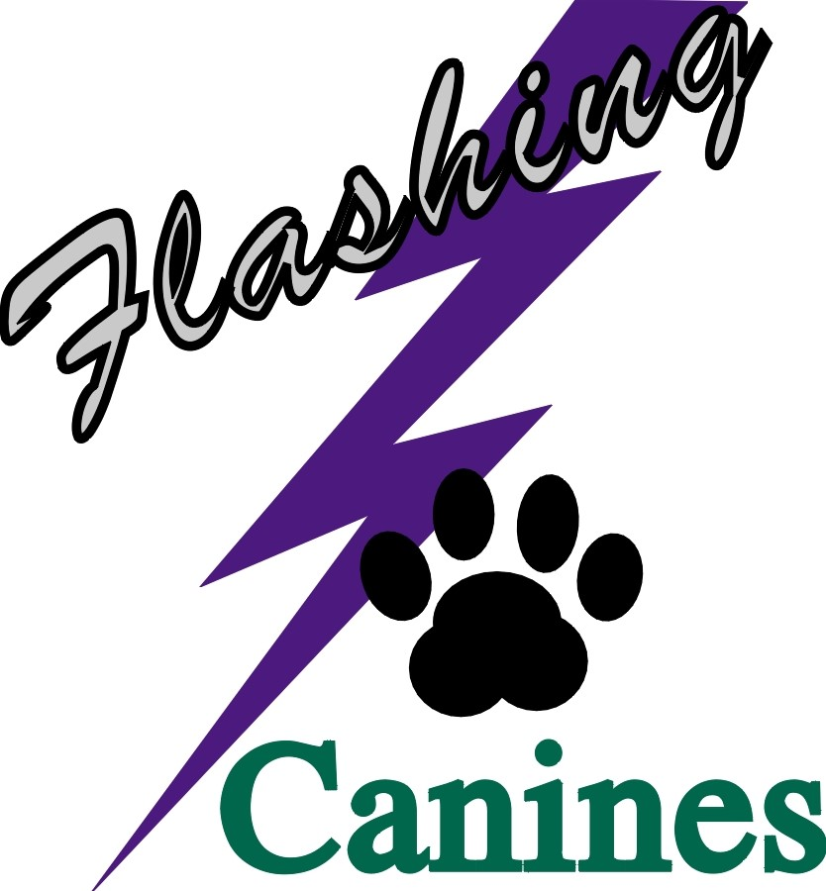
The Flashing Canines
Invite you to join us at our
1 Day March Trial
(A Limited AAC Sanctioned Agility Trial)

March 23rd, 2024
Steiner’s Arena
174055 Highway 875
Tilley, AB

Indoor, Sand Surface

Opening Date: January 22nd, 2024
Closing Date: March 15th, 2024

Electronic Timing
Rubberized Contacts
No One-Piece Jumps

WITH DISTINGUISHED JUDGE

Paula Collins (Alberta)

Classes Offered:

Gamblers – 1 round (Starters, Advanced, Masters)
Standard – 1 round (Starters, Advanced, Masters)
Snooker – 1 round (Starters, Advanced, Masters)
Jumpers – 1 round (Starters, Advanced, Masters)

Tentative Running Order:
Saturday, March 23rd
Gamble 1 (SAM)
Standard 1 (SAM)
Snooker 1 (SAM)
Jumpers 1 (SAM)

*****BIS: Flashing Canines will not be allowing Bitches in Season at this trial, either competing or benching. A refund minus $15 (handling fee) will be given for females (that are entered in the trial) that come into season prior to the trial or come into heat on the trial weekend and at the trial. *****

Trial Chair: Trial Secretary:
Michelle Larson Phone 403-928-8248 Linda Krochak Phone 403-502-0014
email : michellelarsonfk9@hotmail.com email: lindakfk9@gmail.com

Entry Rules | • | Emailed, mailed, hand delivered, or couriered entries will be accepted.
 | • | Cheque, cash, or e-transfer must accompany entry (e-transfer to: payments@flashingcanines.ca – no password deposits) or be received prior to the closing date. E-transfer preferred.
Ribbons and Prizes | • | Rosettes for Titles and Qualifying Rounds
 | • | 1st, 2nd, 3rd, and 4th place will receive flat ribbons
Amenities |  | Please bring food and water for yourselves and your dogs as we will be out of town. There are washroom facilities.

Flashing Canines Official Entry Form: Trial Date: March 23, 2024
Return completed Entry Form with Fees Payable to Flashing Canines Agility Club to Linda Krochak, 54 Northlands Pointe NE, Medicine Hat, AB T1C 0C3, or email entries to lindakfk9@gmail.com and fees to: payments@flashingcanines.ca. Please note that no password is required.

Entries will not be accepted before January 22, 2024, and may not be accepted after March 15, 2024. Dishonoured cheques will be subject to a $20.00 fee

NAME: __________________________________________________________________________________________________
ADDRESS: _______________________________________________________________________________________________
CITY: ________________________________ PROVINCE: _____________________ POSTAL CODE: ___________________
PHONE: ______________________________ EMAIL: ___________________________________________________________
(Confirmations will be sent out by email after the closing date.) Has any of your information changed? (handler or dog) Yes: No:

Dog #1 Dog #2 Dog #3 Dog #4
Dog Information | Name:________________  AAC #: _______________ | Name:________________  AAC #: _______________ | Name:________________  AAC #: _______________ | Name:________________  AAC #: _______________
Handler Name:
Breed:
Birth Date (dd/mm/yy)
Height at Withers:
Dog/Handler Competes in:  * see last page | Regular Specials Vets Vet DD JH Rules SD* | Regular Specials Vets Vet DD JH Rules SD* | Regular Specials Vets Vet DD JH Rules SD* | Regular Specials Vets Vet DD JH Rules SD*
Jump Height at Trial | 4" 8" 12" 16" 20" 24” | 4" 8" 12" 16" 20" 24” | 4" 8" 12" 16" 20" 24” | 4" 8" 12" 16" 20" 24”
Circle event and level | Gambler 1  Starters/Advanced/Master/FEO | Gambler 1  Starters/Advanced/Master/FEO | Gambler 1  Starters/Advanced/Master/FEO | Gambler 1  Starters/Advanced/Master/FEO
 | Standard 1  Starters/Advanced/Master/FEO | Standard 1  Starters/Advanced/Master/FEO | Standard 1  Starters/Advanced/Master/FEO | Standard 1  Starters/Advanced/Master/FEO
 | Snooker 1  Starters/Advanced/Master/FEO | Snooker 1  Starters/Advanced/Master/FEO | Snooker 1  Starters/Advanced/Master/FEO | Snooker 1  Starters/Advanced/Master/FEO
 | Jumpers 1  Starters/Advanced/Master/FEO | Jumpers 1  Starters/Advanced/Master/FEO | Jumpers 1  Starters/Advanced/Master/FEO | Jumpers 1  Starters/Advanced/Master/FEO
 | Individual Runs:  ____ x $15.00 = $__________  Total $__________ | Individual Runs:  ____ x $15.00 = $__________  Total $__________ | Individual Runs:  ____ x $15.00 = $__________  Total $__________ | Individual Runs:  ____ x $15.00 = $__________  Total $__________
Grand Total | $____________________________

AGILITY ASSOCIATION OF CANADA (“AAC”)
PARTICIPATION WAIVER AND RELEASE
Handler Name:
Dog Name: (the “Dog”) AAC Dog ID#:
Dog Name: (the “Dog”) AAC Dog ID#:
Dog Name: (the “Dog”) AAC Dog ID#:
Dog Name: (the “Dog”) AAC Dog ID#:
In consideration of the acceptance of this entry by AAC and Flashing Canines Agility Club (the “Organizing Club”) and the opportunity to have the Dog participate, compete in and/or be judged at this event or trial (the “Event”), I, the undersigned, agree as follows:
- I certify that I am the actual owner of the Dog, or that I am the duly authorized agent of the actual owner of the Dog and that the Dog is not a hazard to persons, property or other dogs.
- I agree that AAC or the Organizing Club for the Event may refuse my entry for any reason that it deems to be sufficient.
- I understand and acknowledge that participation in the Event carries certain risks, including, but not limited to injuries (including serous injuries and death) to myself, the Dog, another dog under my control or persons attending as my guests (my “Related Parties”), damage to property and other losses. I waive any and all claims that I have or may have in the future against, and release from all liability and agree not to sue AAC, the Organizing Club or any of the directors, executives, committees, representatives, employees, volunteers or agents of either AAC or the Organizing Club (the “Personnel”) for any injury, death, property damage or other loss that I or my Related Parties sustain due to any cause whatsoever, including negligence, breach of contract, breach of duty, statutory or otherwise, or mistakes or errors of judgment of any kind.
- I assume full responsibility for the conduct of myself and my Related Parties during the entirety of the Event. I agree to indemnify and save harmless AAC, the Organizing Club and the Personnel from and against any and all claims that may be made against them or costs, fees, expenses or liability (including, without limitation, lawyers’ fees on a solicitor and own client basis) incurred by AAC, the Organizing Club or the Personnel that may arise due to:
(a) any act or omission of myself, my Related Parties or any party for whom I am liable at law; or (b) aggressive behaviour by the Dog or any other dog under my control.
- I have read, and do understand the rules of competition and the additional rules (if any) appearing in the trial schedule for the Event, as well as the policies of AAC pertaining to discipline (collectively, the “Rules”). I agree to abide by the Rules and to conduct myself and the Dog in accordance with the Rules. I understand that myself and/or the Dog may be subject to disciplinary procedures or sanctions for breach of the Rules and agree to respect and be bound by any disciplinary decision made by AAC.
- I understand that AAC and/or the Organizing Club may, in the course of administering the Event or conducting its activities generally, collect, use or disclose my personal information and that any personal information collected, used or disclosed by AAC and/or the Organizing Club will be treated in accordance with AAC policy and applicable privacy and personal information laws. I hereby consent to the collection, use and disclosure by AAC and/or the Organizing Club of my personal information.

Media Release & Rights of Privacy Waiver
I Hereby Grant to AAC and its affiliated companies, representatives, agents and assigns, all rights and permission to use or appropriate his/her and their dog’s name, biography, likeness, photograph, voice, performing persona, or other indicia of identity for broadcast, telecast, cablecast, transmission or distribution in any format or media known now or in the future.

Waiver of Rights to Privacy, Publicity & Personality
Further, I hereby release Agility Association of Canada Inc, and its affiliates, representatives, agents and assigns from any claim or cause of action for invasion of the rights of privacy, right of publicity, right of personality, or any similar rights.
7. I have been given the opportunity to read and understand the terms of this Agreement before signing it, and have in fact done so. I understand that by signing this Agreement, I am restricting my legal rights and I sign this Agreement voluntarily and of my own free will.
Signature: __________________________________________________________
Parent or Guardian must sign if the Handler is under 18 years of age.

Date (dd/mm/yy):____________________________________________________
Entry not valid unless Agreement is signed, dated, and submitted with the correct fee.

The Alberta Freedom of Information and Protection of Privacy Act; enacted January 1st, 2004; requires that consent be obtained for the collection and use of personal information. The information collected by the Flashing Canines Agility Club will be used for:

- Registering competitors in agility events; and
- Contacting competitors by email or mail for future agility events, such as trials and seminars.
All information collected from or pertaining to all competitors will be kept private and confidential unless authorized in writing by the competitor. All paper copies of entries containing personal information will be destroyed after a period of six months.
Notice to Exhibitors
- Exhibitors, through submission of entry, acknowledge they are knowledgeable of the rules and regulations of the AAC, including but not limited to the following:
- This event is held under AAC Rules and Regulations and is open to all dogs being at least 18 months of age, pure bred or mixed breed, except bitches in season, aggressive dogs, or dogs suffering from any deformity or illness which may affect the dog’s physical or mental performance (Judges discretion).
- ** As of January 1, 2001, all dogs must have an AAC number before their entries will be accepted in an AAC sanctioned trial. Dogs with numbers pending will not be eligible to compete.
- Obstacles shall be chosen from those described in the current edition of the rules and regulations of the AAC and shall conform to AAC specifications.
- No food, toys or any other aids or devices shall be permitted on the course at any time. Toys and food shall not be permitted within 10 feet of the ring entrance.
- Dogs will be allowed to wear a close-fitting collar, with no attachments, in the ring.
- **Competitors may place the dog’s leash in their pockets when running the course. The leash must be small enough to fit completely inside the pocket. Note: if the dog grabs the leash while running or jumps at the handler’s pocket to attempt to interact with the leash, this will be scored as an “E” (toy in the ring). If the leash falls out of the pocket during the run and the dog does not interact with it, there will be no fault.**
- All dogs must be penned, crated or leashed when not in the ring. Please take responsibility for your dogs and children. Any exhibitor whose dogs and children create unnecessary disturbances or engage in unsafe or disruptive behaviour may be asked to leave the trial site. There will be no refunds for entries if an exhibitor is dismissed from competition for any reason.

REFUNDS
- Refunds will not be given for cancellations after the closing date except for bitches in season or injury/illness to a dog, or handler, which physically prevents them from competing.
- The Flashing Canines Agility Club reserves the right to request a medical practitioner’s (doctor, vet, chiropractor, or physiotherapist) note prior to issuing any refund and further reserves the right to offer a credit towards a future trial in place of a refund.
- Refunds requested for any other reason will be handled on a case-by-case basis and will be at the discretion of the Trial Committee.
- A $15.00 administration fee will be applied to any refund request.

The Flashing Canines Agility Club reserves the right to refuse any entry

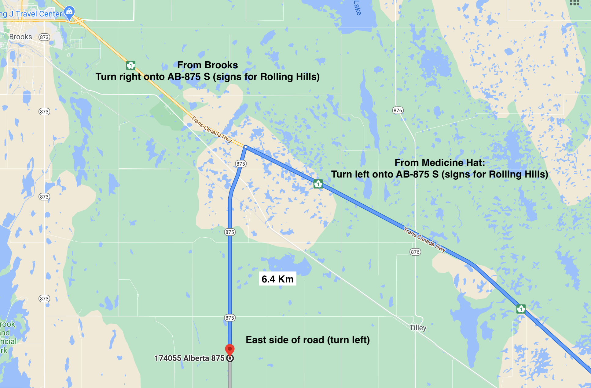
Driving Directions:
